T H E D R I N K S M E N U

BOTTLED BEER
Corona Peroni Budweiser Doom Bar Bulmers
£5 | Single
£5 | Double
£5 | Shots
£5 | Shot x2
£5

SPIRIT & MIXER
£7
£9
£4
£7

IPA
£5 SOFT DRINKS
Pepsi/Pepsi Max

£2 | £3

DRAUGHT BEER
Lemonade
£2 | £3

Estrella
Poretti
£6 J20
£6 Fruit Shoots
£2.50
£1.50

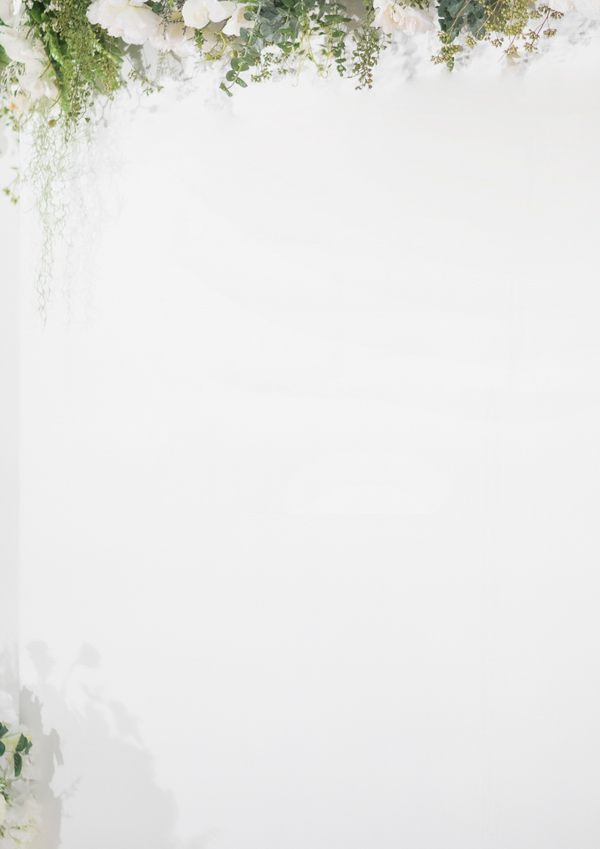

WINE & PROSECCO GLASS £7 | BOTTLE £25
House White House Red House Rose House Prosecco

COFFEE
Americano Expresso Cafe Latte Cappuccino Mocha
Hot Chocolate
Tea

£3.50
£3.50
£3.50
£3.50
£3.50
£3.50
£2

